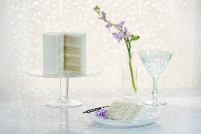
Cake Flavors
- Vanilla Bean White cake with vanilla bean buttercream filling. Nice and light, feels nice and clean. Tastes like vanilla bean ice cream or vanilla bean Frappachino.
Noteworthy: Pure vanilla. You can see the specs of the real vanilla ‘caviar’

- Vanilla w/ Strawberry White cake with a thin layer of strawberry jam and vanilla bean buttercream in every layer. The strawberry adds a lot of flavor, even though it’s a thin line.
Noteworthy: Pure vanilla. Made with REAL strawberries.

- White Almond w/ Raspberry White almond cake with a thin layer of raspberry jam and almond buttercream. Classsic wedding cake flavor.
Noteworthy: Natural almond extract. Jam is made using REAL raspberries.

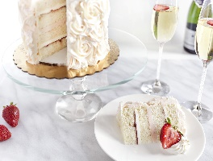
- Strawberries and Champagne Champagne cake, champagne buttercream, strawberry jam, and strawberry buttercream. Classic yet sophistocated.
Noteworthy: Champagne we use is from France. Made using REAL strawberries.

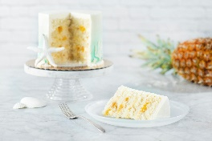
- Coconut w/ Rum Roasted Pineapple Coconut cake, coconut pastry cream, rum roasted pineapple. Refreshing, like a vacation in your mouth!
Noteworthy: Cake is made with coconut milk and dessicated coconut – the tiniest, finest flakes to give the nice light flavor without the usual shredded coconut texture. Coconut pastry cream is made from scratch using coconut milk, and we roast FRESH pineapple in Myers Rum

- Mango Passionfruit Real mango and passionfruit puree is blended into our Swiss buttercream filling and paired with yellow cake. Refreshing, exotic, unique.
Noteworthy: REAL mango and passionfruit

- Lemon Cream Lemon emulsion blended with our Cream Cheese filling, paired with our fresh lemon cake. Light, refreshing, classic.
Noteworthy: We make 2 fillings that are blended together to make 1 filling. Fresh lemons are used for the cake as well as the filling. Lemon emulsion is a fancy nicer name for lemon curd

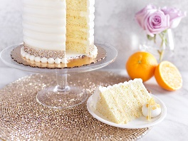
- Orange Creamsicle Orange infused cake with a scratch-made orange creamsicle filling. Refreshing, Florida, childhood memories, fun.
Noteworthy: Fresh oranges. Clean, fresh taste to remind us of the good times in our past
- Lemon w/ Raspberry Basil Jam Fresh lemons infused into the cake and in the bright lemon fillling. Fresh basil added to the end of the cooking process of the raspberry jam. Refreshing, unique
Noteworthy: Inspired by a cocktail. Love pairing fresh herbs with fruit.
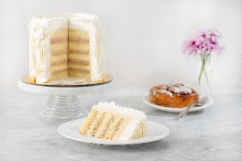
- Key Lime Blueberry Refreshing and Florida! Unique combinatin of key lime and blueberry. Light, bright, unique, and fun.
Noteworthy: Fresh limes and REAL blueberries. Our top seller

- Earl Grey w/ Lemon Lavender Unique and delicious! Earl grey infused cake with a lemon lavender BC filling.
Noteworthy: Real Earl Grey tea is used. The tea leaves are strained out, but the flavor remains! Fresh lemons and subtle lavender compliment the tea. Add raspberry and it tastes like a tea cookie!

- Bananas Foster Banana cake, caramelized banana, and vanilla bean buttercream. Based on the classic dessert, Bananas Foster.
Noteworthy: Fresh bananas are used for the cake, as well as the filling. Fresh bananas are caramelized with Brandy for the Foster filling, and vanilla bean BC represents the ice cream.

- Salted Caramel Smooth, light, and delicious. Housemade caramel drizzled and infused into the filling paired with our classic yellow cake.
Noteworthy: Housemade caramel. Pink Himalayan salt. Not too bitter or powerful of a flavor

- Almond Raspberry Classic flavor combination with a European twist. Almond pound cake, raspberry jam. Flavorful, moist, sweeter than most.
Noteworthy: Cake is made with Almond paste, or Marzipan which gives the cake a denser texture, and a very rich almond flavor.

- Apple Cider Spice Spiced fresh apple cake with apple cider cream cheese filling. Light, refreshing, fall.
Noteworthy: Fresh apples are peeled, cored, and diced. You can taste the love!

- Pumpkin w/ Cinnamon Cream Cheese Light pumpkin cake with cinnamon cream cheese filling. Light, fall/spice, delicious
Noteworthy: Super light. Very light cinnamon spice in the cream cheese filling. Smooth and velvety

- Hummingbird If carrot cake and banana cake got together and had a baby, it would be Hummingbird. It’s a spiced cake, yet refreshing with the pineapple, banana, and silky smooth cream cheese filling.
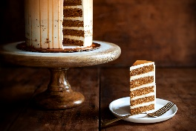
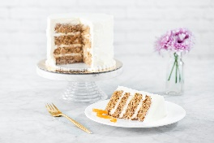
- Carrot A Southern classic! Spiced cake with pineapple, pecans, and cream cheese filling.
Noteworthy: We omit the raisins, but can be added by client’s request.

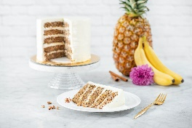
- Cinnamon Roll A new way to enjoy the delicious flavors of a classic cinnamon roll! Not too powerful, yummy cinnamon roll cream cheese paired with yellow cake
Noteworthy: Everything is made in-house.
- Bailey’s and Macadamia A unique cake with a surprise crunch. Macadamia meringue is baked so the nuts are nice and toasty and the meringue is light and crispy. Bailey’s is infused into the cake and added into the cream cheese filling.
Noteworthy: Bailey’s is infused into the cake after it bakes. 2 layers of macadamia nut meringue – top and bottom of the cake tier.

- Chocolate Chip Cannoli An italian classic in the form of a cake! Chocolate cake, yellow cake, and a cannoli shell meringue. Scratch made choc. chip cannoli filling in each layer
Noteworthy: Cannoli filling made with ricotta impastata (not what you get in the grocery store)

- Red Velvet A Southern American classic! Light, soft cake with silky smooth cream cheese frosting.
Noteworthy: We currently use red food coloring to dye the cake. We use European cocoa in the batter

- Pistachio Soft and smooth, made with REAL pistachios, no food colorings.
Noteworthy: Pistachio paste we use to flavor/color the cake and filling is imported from Italy (it’s what they use to flavor gelato)

- Marble w/ Ganache Marble cake with rich chocolatey ganache filling. Chocolate lovers in disquise! Decadent yet balanced.
Noteworthy: Chocolate comes from Europe! Dark chocolate that melts in your mouth.
- Chocolate Strawberry Resembles the classic ice cream – Neopolotin. Chocolate cake and buttercream flavored and colored using REAL strawberries.
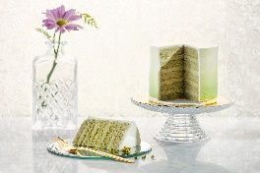
Noteworthy: Strawberries we use in the buttercream are from France resulting in a very flavorful filling. Strawberries are pureed so no chunks of fruit. Compliments the chocolate cake perfectly

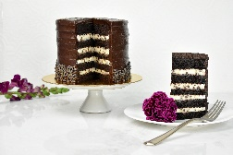
- Chocolate Raspberry Rich and delicious. European chocolate cake with flavorful raspberry filling. Made using REAL raspberries.
Noteworthy: We’re told it tastes like a raspberry chocolate truffle.

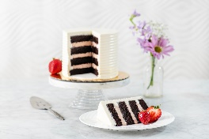
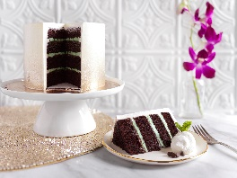
- Mint Chocolate Chip European chocolate cake, mint chocolate chip filling. Refreshing! Tastes like the ice cream rather than toothpaste.
Noteworthy: Mint paste is imported from Italy (used to flavor gelato) Mint ganache (us to know)

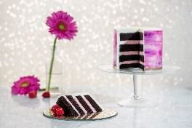
- Chocolate Chip Cream Cheese Chocolate cake with rich chocolate chip cream cheese filling. Rich and delicious!
Noteworthy: European cocoa for the cake. Cream cheese is silky smooth and creamy. Tiny little chocolate chips add a fun texture
Tasting: 3 layers of chocolate cake. 2 layers of chocolate chip cream cheese. Reg. BC on top
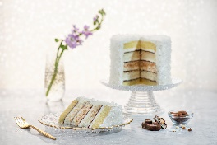
- Joyful Chocolate Almond Almond pound cake with light coconut cake and a surprise coconut almond meringue crunch in the center. A thin layer of ganache and toasted coconut BC in all layers
Noteworthy: Our take on the classic candy bar! Each bite is different. Light and airy, not a strong coconut flavor.
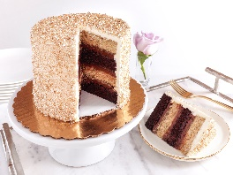
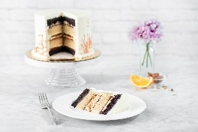
Tasting: almond # on bottom. Then coconut cake, then meringue on top. Thin layer of gananche and toasted coconut bc in both fillings. Reg. BC on top. ** contains tree nuts and coconuts!
- Chocolate Covered Banana SO flavorful! Alternating layers of banana cake and chocolate cake. Filling in each layer comprises of chocolate ganache and caramelized banana, and chocolate covered crispies for that little extra crunch.
Noteworthy: Based on one of my favorite treats, frozen chocolate covered bananas. The chocolate
covered crispies provide that ‘crunch’ of the chocolate shell. Made using fresh bananas.
Tasting: Chocolate cake bottom, banana, then chocolate cake. 2 layers of filling: ganache, crunchies,
then foster filling.
- Chocolate Orange Almond Almond Financier cake, chocolate cake, and a crunchy almond meringue in the center. Orange ganache and orange creamsicle filling in each layer. Rich, flavorful, fun.
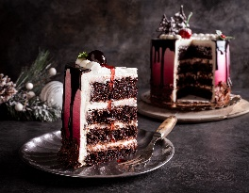
Noteworthy: Based on another childhood favorite; those chocolate oranges you find in your stocking

Black Forest European classic. Chocolate cake, cherry compote, and amaretto mascaropone filling. Creamy, flavorful.
Noteworthy: NOT marachino cherries. Real cherries and no food dyes.

- Mocha Chocolate cake infused with coffee and Kahlua. Chocolate coffee Swiss buttercream filling. Smooth. Decadent. Flavorful.
Noteworthy: Kahlua and coffee infused into the cake after it bakes.

- Chocolate Peanut Butter Chocolate cake, peanut butter mousse filling, surprise crunch on the bottom layer. Rich, Intense, Decadent.
Noteworthy: We make our own peanut butter here at the bakery!

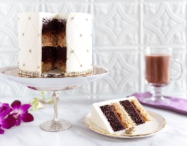
- Hazelnut w/ Kahwa Espresso SO FLAVORFUL! Every bite is different. Alternating layers of Chocolate and Hazelnut Financier. Fillings of Hazelnut buttercream, espresso ganache, and a hazelnut crunch also alternate. Intense!
Noteworthy: Espresso bean comes from local coffee company, Kahwa Coffee. So delicious!

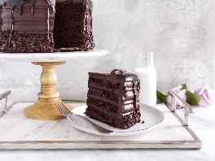
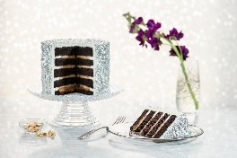
Chocolate Chocolate The name says it all! Chocolate cake with chocolate frosting filling.
Noteworthy: European chocolate. Let the ingredients speak for themselves.

